|  |  |  |  |
| --- | --- | --- | --- |
| Name:  Class: | ____________________________________  ________________ | | Date: ___________ |
|  | **Year 11 Essential Mathematics Unit 2**  SCORE:  /37    **Test 8 2018**  **Topic – Time and timetables**  ***Full working out MUST be shown to get full marks for each question.*** | | |
| **Total Time:** | 45 minutes |  | |
| **Weighting:** | 4 % |
| **Equipment:** | To be provided by the student: Pen, pencil, ruler, scientific calculator, 1 single sided page of A4 notes | | |

**Question 1**

Convert the following times below into different units. [6 marks]

1. ¼ century = _______years
2. 669 days = ________ months
3. 90 days = _________ years
4. 3.5 years = ________weeks
5. 367,200 seconds = _________days
6. 12,340 minutes = _________ weeks

**Question 2**

Complete the following table. (5 marks)

|  |  |
| --- | --- |
| **24 hour time** | **12 hour time** |
| 0013 |  |
|  | 4:56 pm |
| 0934 |  |
| 2156 |  |
|  | 12:16pm |

**Question 3**

Marcus is looking forward to his favourite tv show which starts at 5:30pm. It is currently 2:55pm. How long does he need to wait? [2 marks]

**Question 4**

Bradley is picking his 3 friends Steve, Marsha and Beryl to go to a restaurant. It will take 11 minutes to get from Bradley’s house to Steve’s, 7 minutes to get from Steve’s house to Marsha’s, 6 minutes to get from Marsha’s to Beryl’s and then 4 minutes to get from Beryl’s house to the restaurant. What time does Bradley need to leave home if the restaurant booking is for 7:30pm? [4 marks]

**Question 5**

Mark needs to get from Roma Street Station in Brisbane to the Brisbane Domestic Airport as close to 1:30pm as he can. Below are two timetables - one for the train, the other for a bus: [7 marks]

Train timetable:

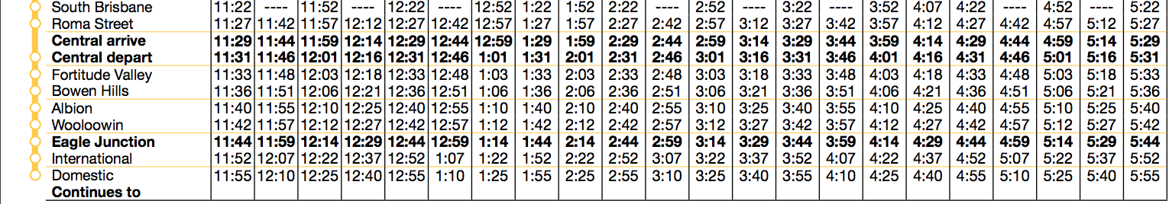

Bus timetable (Note: Brisbane Coach Terminal = Roma Street Station):

1. What time would you need to depart Roma Street to arrive at the airport in time for the train?
2. What time would you need to depart Roma Street to arrive at the airport in time for the bus?
3. How long will it take you to travel to the airport via the train? Show working out
4. How long will it take you to travel to the airport via the bus? Show working out
5. Which method of transport was faster?

**Question 6**

Juliet is in training for the city to surf half marathon. She runs every day. On Monday, Wednesday and Friday she runs in the morning and after work. Tuesday and Thursday she runs in the morning and rests after work. On weekends, she runs for hours each day.

How long does Juliet run each week? Give your answer in hours and minutes. [5 marks]

**Question 7**

In March 2018, Kane’s television was years old. When did Kane buy the television? Write the month and year. [3 marks]

**Question 8**

The table below shows the tide heights at a beach for the first two weeks of September. [10 marks]



1. At what time did the high tides occur on the 4th?
2. What day and time did the high tide of the greatest height occur?
3. What is the time difference between the high and low tides on the morning of the 6th?
4. The best time to go surfing is 30 minutes before and after high tide. Jonathan prefers to surf in the mornings before going to work what is the earliest time he can surf on.
5. 5th September
6. 10th September
7. Jonathan and his family are going on a holiday from the 6th – 12th of September to Busselton. When the weather is good, they like to go fishing. To ensure they don’t destroy the local reef or their boat, they prefer to depart on a fishing trip 45 minutes after 0.7m low tide. What days and times can they go out fishing?